“The Only Wheelchair in Town” - a memoir by Rick Hansen and Jim Taylor
- from the autobiography Rick Hansen: Man in Motion

Rick Hansen: Born 1957, Port Alberni, British Columbia
In 1973, Rick Hansen became a paraplegic as the result of an automobile accident. Hansen became focussed on a goal: to increase public support and awareness of the capabilities of the physically disabled. Inspired by fellow Canadian and friend Terry Fox, Hansen left Vancouver on March 21, 1985, to begin his Man in Motion tour. Travelling in his wheelchair the equivalent of the distance around the world, Hansen raised $23 million on his 792-day journey through thirty-four countries. In 1987 Hansen received the Order of Canada and published his life story, Rick Hansen: Man in Motion.
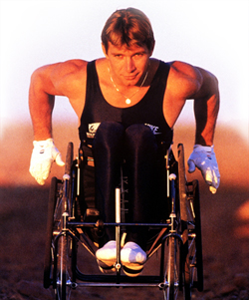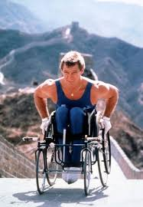At the Great Wall of China

I remember once on that first Christmas after I came back to stay, a bunch of the kids decided
to go to Blue Lake for the weekend. It was all snowed in, and I was put off because I couldn’t
make it. But they got a toboggan, grabbed the ropes and hauled me in. We could have had the
greatest time – but I was sitting there sulking because I had to be tobogganed in. I wrecked the
entire evening. We stayed overnight and came back the next day. It was okay, but I’d acted
like a little wimp.

I know part of the reason. It was the old boy-girl thing and I was self-conscious. Because by
that time, I had a girl. Yet, I was still in the chair, or on the braces and crutches. Why was she
going out with me? How long before she dropped me for someone else? What did the other
kids think about it?

Yeah, I know: I’d written off women before they could write me off. It was funny the way I
changed my mind. My brother, Brad, had a crush on a girl named Kim Belcher who played on
one of the school volleyball teams, but was too shy to ask her out. I razzed him about it and
kept telling him I was going to phone her and set up a date for him. He thought I was kidding
until I did it.

Well, she said yes, and the thing was a lock until I told Brad. He wimped out, phoned her, and
explained that the whole thing had been my idea and he didn’t want a date. So where did that
leave me? Obviously, I owed her an apology.

I got as far as the phone when it hit me: this is a cute girl! Why am I asking her out for him? I
want to ask her out for myself. So I did, we went for a drive, and that’s how I had my first kiss
at the ripe old age of sixteen.

That was a bit of a confidence builder, but I still didn’t think any girl would go steady with me or
anything like that. Then one day in grade eleven science I noticed this girl name Isobel at the
back of the room who kept looking up front at me and smiling. At first I didn’t smile back. She
couldn’t be smiling at me. Then I noticed there was no one in front of me but the teacher and
she couldn’t be smiling at him. “Hey,” I thought. “She is smiling at me.” Then I gave it up.
Probably just felt sorry for me.

But she’d come up and talk to me, and one day she drove in her friend’s old car to where I was
lying on the grass. She asked me out to a show, and we wound up dating for about three
months. Wait a minute! Maybe they didn’t just feel sorry for me. Maybe girls weren’t out of
the question.

I started asking girls out instead of waiting to be asked. Son of a gun! It worked. By grade
twelve I was going steady with a girl named Patti Lueke who played on the grade eleven
volleyball team I was helping to coach. We went out rather seriously for about the next three
years. In fact, it was Patti I was with on the Blue Lake expedition.

So why was I being such a jerk? Because through it all I was still pretty insecure. I was jealous
of the other guys. I’d look at Patti and think, “What can she possibly see in me? Why is she
with me when she can be with one of them?” At parties I’d just sit back and watch. I was
embarrassed over my legs, which had wasted away to next to nothing after being so big and
solid and well defined. We’d go to the lake, and the gang would be saying, “C’mon down! We’ll
carry you to the bank.” Not me. I’d sit in the truck on the road waiting while they were down
in the water swimming. We’d go on a picnic, and I’d barely make an effort to do anything. I
was just sitting there feeling sorry for myself and trying to make as many people as possible feel
sorry for me.

There was no future in it. Deep down I think I knew that. But my education was just getting
started.

There’s nothing wrong with being carried down a bank by your friends so you can go swimming.
What’s wrong with taking your clothes off and going in shorts and letting people see that
you’ve got skinny legs? It’s no big deal.

Rick Hansen: co-Mayor of Vancouver Olympics With his wife and three daughters
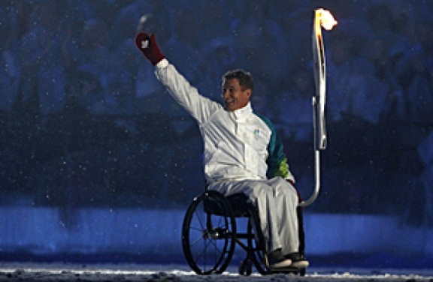

Activity: Recall an important event that happened to you between the ages of five and twelve. Brainstorm about how this event made you feel at the time it happened. Then, brainstorm how this event makes you feel now. What changes have you discovered in your view of this event?
Write a paragraph about how you felt when the event happened. Write a second paragraph about how you feel about the event now.

